BURJ KHALIFA
Facts from Wikipedia
Burj Khalifa (Arabic: برج خليفة‎ "Khalifa Tower"),^{[2]} formerly known as Burj Dubai, is a skyscraper in Dubai, United Arab Emirates, and the tallest man-made structure ever built, at 828 m (2,717 ft).^{[2]} Construction began on 21 September 2004, with the exterior of the structure completed on 1 October 2009. The building officially opened on 4 January 2010.
The total cost for the Burj Khalifa project was about US$1.5 billion; Current records
Tallest skyscraper to top of spire: 828 m (2,717 ft) (previously Taipei 101 – 509.2 m/1,671 ft)
Tallest structure ever built: 828 m (2,717 ft) (previously Warsaw radio mast – 646.38 m/2,121 ft)
Tallest extant structure: 828 m (2,717 ft) (previously KVLY-TV mast – 628.8 m/2,063 ft)
Tallest freestanding structure: 828 m (2,717 ft) (previously CN Tower – 553.3 m/1,815 ft)
Building with most floors: 160 (previously Willis Tower – 108)^{[17]}
World's highest elevator installation,situated inside a rod at the very top of the building^{[18][19]}
World's fastest elevators at speed of 64 km/h (40 mph) or 18 m/s (59 ft/s)^{[19]} (previously Taipei 101 – 16.83 m/s)
Highest vertical concrete pumping (for a building): 606 m (1,988 ft)^{[20]} (previously Taipei 101 – 449.2 m/1,474 ft)
Highest vertical concrete pumping (for any construction): 606 m (1,988 ft)^{[20]} (previously Riva del Garda Hydroelectric Power Plant – 532 m/1,745 ft^{[21]})
The first world's tallest structure in history to include residential space^{[22]}
Highest outdoor observation deck in the world (124th floor) at 442 m (1,450 ft)^{[23]} ^{[24][25]}
World's highest mosque (located on the 158th floor)^{[26][27]}
World's highest installation of an aluminium and glass façade, at a height of 512 m (1,680 ft)^{[28]}
World's highest swimming pool (76th floor)^{[26]} (previously Shanghai World Financial Center – 85th floor)
The design of Burj Khalifa is derived from patterning systems^{[38]} embodied in Islamic architecture. According to the structural engineer Bill Baker of Burj Khalifa, the building's design incorporates cultural and historical elements particular to the region. The Y-shaped plan is ideal for residential and hotel usage, with the wings allowing maximum outward views and inward natural light.^{[39]} The design architect Adrian Smith has said the triple-lobed footprint of the building was inspired by the flower Hymenocallis.^{[40]} The tower is composed of three elements arranged around a central core. As the tower rises from the flat desert base, setbacks occur at each element in an upward spiralling pattern, decreasing the cross section of the tower as it reaches toward the sky. There are 27 terraces in Burj Khalifa. At the top, the central core emerges and is sculpted to form a finishing spire. A Y-shaped floor plan maximizes views of the Persian Gulf. Viewed from above or from the base, the form also evokes the onion domes of Islamic architecture. During the design process, engineers rotated the building 120 degrees from its original layout to reduce stress from prevailing winds. At its tallest point, the tower sways a total of 1.5 m (4.9 ft).^{[41]} To support the unprecedented height of the building, the engineers developed a new structural system called the buttressed core, which consists of a hexagonal core reinforced by three buttresses that form the ‘Y' shape. This structural system enables the building to support itself laterally and keeps it from twisting^{[42]}. The spire of Burj Khalifa is composed of more than 4,000 tonnes (4,400 ST; 3,900 LT) of structural steel. The central pinnacle pipe weighing 350 tonnes (390 ST; 340 LT) was constructed from inside the building and jacked to its full height of over 200 m (660 ft) using a strand jack system. The spire also houses communications equipment.^{[43]}
The exterior cladding of Burj Khalifa consists of 142,000 m² (1,528,000 sq ft) of reflective glazing, and aluminium and textured stainless steel spandrel panels with vertical tubular fins. The cladding system is designed to withstand Dubai's extreme summer temperatures. Additionally, the exterior temperature at the top of the building is thought to be 6°C (11°F) cooler than at its base.^{[45]} Over 26,000 glass panels were used in the exterior cladding of Burj Khalifa. Over 300 cladding specialists from China were brought in for the cladding work on the tower.^{[43]}
Burj Khalifa will receive its first residents from February 2010. They will be among the first of 25,000 people who will live there.^{[50][51]} The outdoor observation deck, opened on 5 January 2010, is the highest in the world, at 442 m (1,450 ft). Tickets are time stamped at 30-minute intervals, on specific days, in order to carefully manage the daily rush of sightseers. Introductory ticket price is AED 100 for adults and AED 75 for children up to 12 years.^{[52]}
Burj Khalifa is expected to hold up to 35,000^{[53]} people at any one time.^{[54]} A total of 57 elevators and 8 escalators are installed,^{[43]},with the capacity of 12 to 14 people per cabin^{[55]} the fastest rising and descending at up to 18 m/s (59 ft/s).^{[56]} Engineers had considered installing the world's first triple-deck elevators, but the final design calls for double-deck elevators.^{[22]}Double-deck elevators, are with built in light and entertainment features including LCD displays, which serves the visitors throughout their travel to the Observation deck^{[57]} The building has 2,909 stairs from the ground floor to the 160th floor.^{[58]}
Water supply system
The Burj Khalifa's water system will supply an average of about 946,000 litres of water per day. At the peak cooling times, the tower will require approximately 10,000 tonnes of cooling per hour, which is equivalent to the capacity provided by 10,000 tonnes (22.4 million lbs or 10.2 million kg) of melting ice in one day^{[61]}.
The building has a condensate collection system, which uses the hot and humid outside air, combined with the cooling requirements of the building and will result in a significant amount of condensation of moisture from the air. The condensed water will be collected and drained into a holding tank located in the basement car park,this water will then be pumped into the site irrigation system for use on the Burj khalifa park^{[62]}.
Maintenance
To wash the 24,348 windows, a horizontal track has been installed on the exterior of Burj Khalifa at levels 40, 73 and 109. Each track holds a 1,500 kg (3,300 lb) bucket machine which moves horizontally and then vertically using heavy cables. Above level 109, up to tier 27 traditional cradles from davits are used. The top of the spire, however, is reserved for specialist window cleaners, who brave the heights and high winds dangling by ropes to clean and inspect the top of the pinnacle.^{[63]} Under normal conditions, when all building maintenance units will be operational, it will take 36 workers three to four months to clean the entire exterior facade.^{[43][64]}
Unmanned machines will clean the top 27 additional tiers and the glass spire. The cleaning system was developed in Australia at a cost of A$8 million.^{[64]}

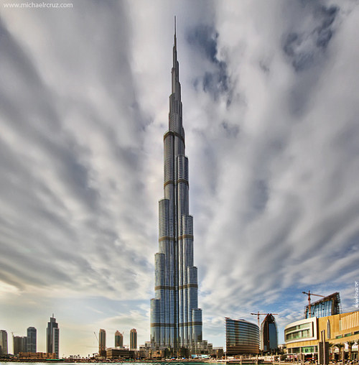

http://www.skyscraper.org/TALLEST_TOWERS/t_petronas.htm
The Petronas Towers
Height: 1,483 ft (452 meters)
Owners: Kuala Lumpur City Centre Holdings Sendirian Berhad
Architects: Cesar Pelli & Associates
Engineers: Thornton-Tomasetti Engineers
Contractors: Mayjus and SKJ Joint Ventures
Topping Out: 1998
Official Opening: August 28, 1999
On April 15, 1996, the Council on Tall Buildings named the Petronas Towers the tallest in the world, passing the torch to a new continent. Although the project's developers, a consortium of private investors in association with the Malaysian government and Petronas, the national oil company, had not originally set out to surpass Chicago's Sears Tower, they did aspire to construct a monument announcing Kuala Lumpur's prominence as a commercial and cultural capital. In the design of American architect Cesar Pelli they found a winning scheme--twin towers of elegant proportions with a slenderness ratio (height to width) of 9.4--that would capture not only the title but the public imagination.
Pelli's design answered the developer's call to express the 'culture and heritage of Malaysia' by evoking Islamic arabesques and employing repetitive geometries characteristic of Muslim architecture. In plan, an 8-point star formed by intersecting squares is an obvious reference to Islamic design; curved and pointed bays create a scalloped facade that suggests temple towers. The identical towers are linked by a bridge at the 41st floor, creating a dramatic gateway to the city.
The structure is high-strength concrete, a material familiar to Asian contractors and twice as effective as steel in sway reduction. Supported by 75-by-75-foot concrete cores and an outer ring of widely-spaced super columns, the towers showcase a sophisticated structural system that accommodates its slender profile and provides from 14,000 to 22,000 square feet of column-free office space per floo
Other features include a curtain wall of glass and stainless steel sun shades to diffuse the intense equatorial light; a double-decker elevator system with a sky lobby transfer point on the 41st floor to accommodate the thousands of people who use the complex daily; and a mixed-use base featuring a concert hall and shopping center enveloped by nearly seventy acres of public parks and plazas.
In both engineering and design, the Petronas Towers succeed at acknowledging Malaysia's past and future, embracing the country's heritage while proclaiming its modernization. The end result, says Pelli, is a monument that is not specifically Malaysian, but will forever be identified with Kuala Lumpur.
http://www.pbs.org/wgbh/buildingbig/wonder/structure/petronas_towers.html
- The Petronas Towers were featured in the blockbuster movie Entrapment, starring Sean Connery and Catherine Zeta-Jones.
- It took 36,910 tons of steel to build the Petronas Towers. That's heavier than 3,000 elephants!
- It takes 90 seconds to travel from the basement parking lot to the top of each tower.
- Together, the towers have 32,000 windows. It takes window washers an entire month to wash each tower just once!

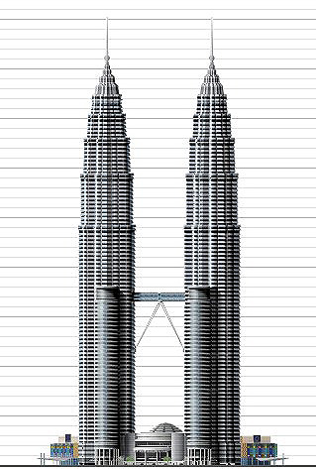

Sears Tower
Sears Tower
(4.5 million ft2)
Chicago, Illinois (1974)
1,454 feet, 443.0 meters, 110 stories
Constructed 1970-1974
In the late 1960s, Sears Roebuck and Company, then the world's largest retailer with $8.9 billion in sales, decided to consolidate its administrative operations in downtown Chicago. The company determined it needed 3 million ft2 of office space with floors of 50,000 ft2 to accommodate its 13,000 employees in their major departments.
The first designs were for a boxy structure exclusively for Sears, but the architects and real estate advisors pressed for a taller tower with upper floors for tenants. The building slowly stretched to 4.5 million ft2 and 110 stories, and in July 1970, Sears trumpeted its plans for the world's tallest building. At 1454 feet, its height surpassed the World Trade Center by 100 feet and was, according to Sears "as tall as the FAA (Federal Aviation Administration) will let us go." For more than twenty years after its completion in 1974, Sears Tower remained the tallest skyscraper, and it is still the largest.
As designed by architect Bruce Graham and engineer Fazlur Khan of the Chicago office of Skidmore Owings and Merrill (SOM), the structure was a "bundled tube" system of nine squares with sides of 75 feet (for an overall 225 x 225 ft), sheathed in a curtain wall of dark tinted glass. Above the fiftieth floor, some squares dropped away as the tower rose to create smaller floor plates and a distinctive stepped silhouette. The Tower is fronted by a separate tourist entrance, the Skydeck Pavilion added in 1985 by Skidmore Owings and Merrill. The Sears attracts some 1.5 million tourists each year, despite the loss of its title to the Petronas Towers in Kuala Lumpur in 1997. Though no longer the tallest building in the world, the Tower is still title to the world's highest occupiable floor and the highest roof deck and elevator ride. On a clear day it is possible to see four states from the top. http://www.pbs.org/wgbh/buildingbig/wonder/structure/sears_tower.html
Vital Statistics:
Location: Chicago, Illinois, USA
Completion Date: 1973
Cost: $150 million
Height: 1,454 feet
Stories: 110
Materials: Steel
Facing Materials: Black aluminum
Engineer(s): Skidmore, Owings & Merrill
The Sears Tower is an example of the revolutionary bundled-tube structural design. Tube buildings gain most of their structural support from a rigid network of beams and columns in their outer walls. The rigid outer walls act like the walls of a hollow tube. The Sears Tower is actually a bundle of nine tubes, and is considered one of the most efficient structures designed to withstand wind. This is a great design for a skyscraper in Chicago, the "Windy City," where the average wind speed is 16 miles per hour. As the building climbs upward, the tubes begin to drop off, reducing the wind forces on the building. The Tower's heavy weight -- more than 440 million pounds -- is also supported by 114 piles sunk deep into the earth so that they stand firmly on hard, solid bedrock.
In 1974, the Sears Tower in Chicago assumed the coveted title of world's tallest building, at 1,454 feet. It held this title for 22 years until 1998, when the decorative spires atop the Petronas Towers in Malaysia surpassed the Sears Tower by 33 feet. Today, the Sears Tower still boasts the tallest occupiable floor and the tallest skyscraper roof in the world.
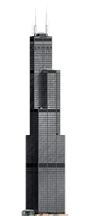
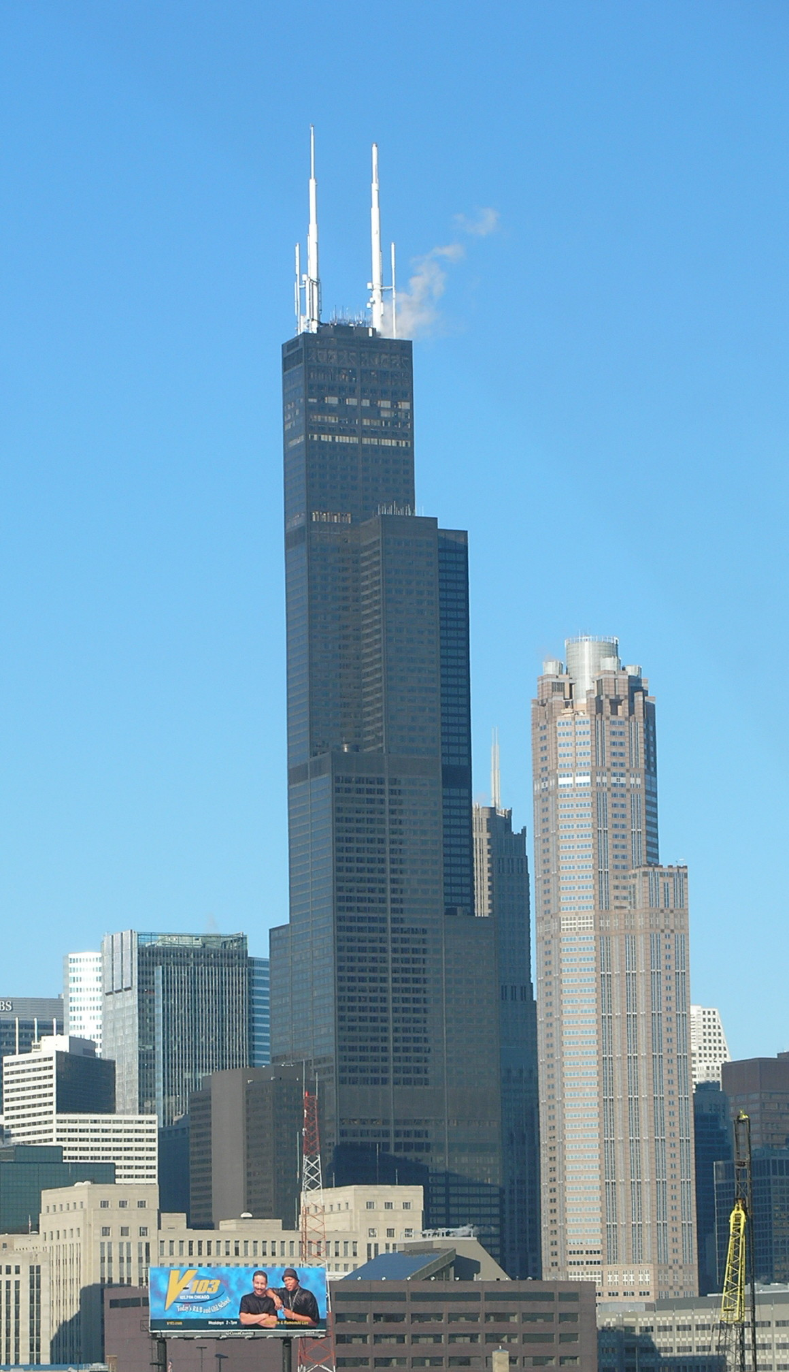

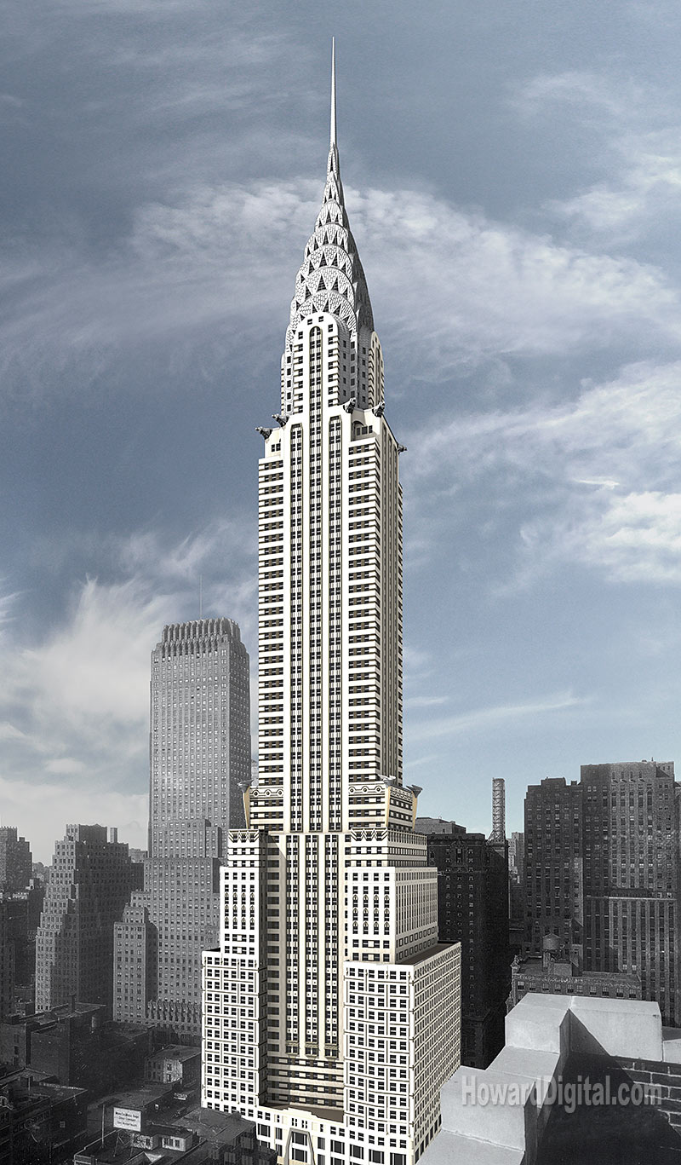
CHRYSLER BUILDING
405 Lexington Ave.
Height: 319 m /1,046 ft Floors: 77
The 1,046-foot Chrysler Building was the tallest building in the world from 1930 to 1931 and was part of an intense race for this title. In 1928, developer William H. Reynolds hired William Van Alen to design the world's tallest building for a site leased at the northeast corner of Lexington Avenue and 42nd Street, across from Grand Central Station. Later that year, Reynolds sold both lease and plans to Walter P. Chrysler, who wanted to build a new headquarters for the Chrysler Corporation. Van Alen altered the plans to reflect his new patron: a domed lantern became a metal clad spire; the frieze on the 30th floor became a line of hubcaps; new gargoyles were enormous, Chrysler Eagle radiator caps; fenders and hood ornaments became part of the decoration.
Groundbreaking took place on September 19th, 1928. In 1929, however, Van Alen's former partner, H. Craig Severance, began work on an even taller building at 40 Wall Street for the Bank of The Manhattan Company. Not to be outdone, Van Alen secretly had an 185-foot spire built within the fireshaft of the Chrysler Building. As soon as Severance had completed his 927-foot structure in August 1930, Van Alen had the 27-ton spire raised to the top of the Chrysler Building in a mere 90 minutes, surpassing his downtown rival handily.
The Chrysler Building has an H-plan with setbacks at the 16th, 23rd and 30th floors. The main shaft rises 68 floors, although offices only go up to the 65th (the 66th through 68th housed the exclusive Cloud Club and an observation lounge). Four banks of eight elevators each brought up over one thousand workers and visitors daily at an unprecedented speed. The novel use of aluminum and chrome-nickel steel for exterior details was mirrored in an interior of luxury; elaborate, wood marquetry, rich, varied marbles, and dramatic custom lighting created an interior as theatrical as its exterior.
Van Alen and Chrysler fell out over allegations of contractors' bribery; the Chrysler Corporation never fully utilized its space and Van Alen's career virtually ended. Moreover, critics were unimpressed with the building, calling its metal-clad form too "romantic," "overly ambitious," or even worse, "merely advertising." However, it is just these aspects that make the building perhaps the most notable of New York's skyline.
When completed, it became the tallest man-made structure in the world, surpassing even the Eiffel Tower in Paris. Its reign was short lived. On May 1st, 1931 the 1,250-foot Empire State Building opened at 350 Fifth Avenue (Shreve, Lamb & Harmon) and became the World's Tallest Building for over four decades.
Vital Statistics:
Location: New York, New York, USA Completion Date: 1930
Cost: $20 million Height: 1,046 feet Stories: 77 Materials: Steel
Facing Materials: Brick Engineer(s): Ralph Squire & Sons
In the summer of 1929, a "race for the sky" broke out on the island of Manhattan. Automobile tycoon Walter Chrysler battled Wall Street powerhouse Bank of Manhattan Trust Company for the title of world's tallest building in what many historians consider to be the most intense race in skyscraper history. In the spring of 1930, just when it appeared that the bank might capture the coveted title, a small crew jacked a needle-thin spire hidden in Chrysler's building through the top of the crown to claim the title of world's tallest at 1,046 feet.
Not only was the Chrysler Building the world's tallest structure, it was also one of the most decorated office buildings in the world. Chrysler wanted "a bold structure, declaring the glories of the modern age" -- and he got it. He decorated his skyscraper with hubcaps, mudguards, and hood ornaments, just like his cars, hoping that such a distinctive building would make his car company a household name. Today, the Chrysler Building is recognized as New York City's greatest display of Art Deco, a decorative style characterized by sharp angular or zigzag surface forms and ornaments.

EMPIRE STATE BUILDING
Tallest building in the world when it was completed in April 1931, the EMPIRE STATE broke every record in the book. At 1250 feet, it topped the Chrysler Building by 200 feet and the third tallest, the Manhattan Company Building at 40 Wall Street, by more than 300 feet. Gargantuan in SCALE, its five-story base covered two acres and its eighty-five floors of offices boasted more rentable space – 2.1 million square feet – than the Chrysler Building and 40 Wall Street combined.
The most astounding statistic of the Empire State, though, was the extraordinary SPEED with which it was planned and constructed. Within just TWENTY MONTHS from the first signed contracts with the architects in September 1929, the Empire State was designed, engineered, erected, and ready for tenants. Six months after the first structural columns were set in April 1930, the steel frame topped out on the eighty-sixth floor. The fully enclosed building, including the mooring mast that raised its height to the equivalent of 102 stories, was finished within eleven months, in March 1931. At peak activity, 3,500 workers were employed on site, and the tower rose A STORY A DAY.
During this twenty months, architectural and engineering drawings were prepared, the massive Waldorf-Astoria Hotel was demolished, the foundations and grillages were dug and set, 57,000 tons of structural steel were fabricated and milled to precise specifications. Ten million common bricks were laid, 62,000 cubic yards of concrete were poured, 6400 windows were set, and 67 elevators were installed in 7 miles of shafts. Interiors were equipped with 6,700 radiators, 2,500 toilets and sinks, and 51 miles of plumbing pipe, and were finished with 10,000 tons of plaster and 328,000 square feet of marble.
Location: New York, New York, USA Completion Date: 1931
Cost: $41 million Height: 1,250 feet Stories: 102 Materials: Steel
Facing Materials: Limestone, granite, brick Engineer(s): H.G. Balcom
Built during the Depression between 1930 and 1931, the Empire State Building became the world’s tallest office building – surpassing the Chrysler Building by a whopping 204 feet. The design of the building changed 16 times during planning and construction, but 3,000 workers completed the building’s construction in record time: one year and 45 days, including Sundays and holidays. The Empire State Building is composed of 60,000 tons of steel, 200,000 cubic feet of Indiana limestone and granite, 10 million bricks, and 730 tons of aluminum and stainless steel.
Steel columns and beams form a stable 3-D grid throughout the entire structure. But since such closely spaced column grids obstruct open spaces in buildings, there are virtually no open spans, or column-free spaces, on each floor of the Empire State Building.
The Empire State Building remained the tallest building in the world for 41 years. In 1972, the World Trade Center claimed this distinction. Today, despite being surpassed in height by six other towers, the Empire State Building remains an internationally known landmark and arguably the most famous building ever constructed.
In 1945, a B-25 bomber on its way to Newark Airport in New Jersey crashed into the 79th floor of the Empire State Building. Amazingly, the building suffered only minor damage. The Empire State Building contains 3,194,547 light bulbs, 50 miles of radiator pipe, 70 miles of water pipe, 1,060 miles of telephone cable, and 7,450 tons of refrigeration equipment. One hundred tons of trash and waste are removed from the building each month. The Empire State Building is designed to serve as a lightning rod for the surrounding area. It is struck by lightning about 100 times per year. There are 1,575 steps from the building’s lobby to the 86th floor. Paul Crake holds the record for racing these steps in 10 minutes, 15 seconds.

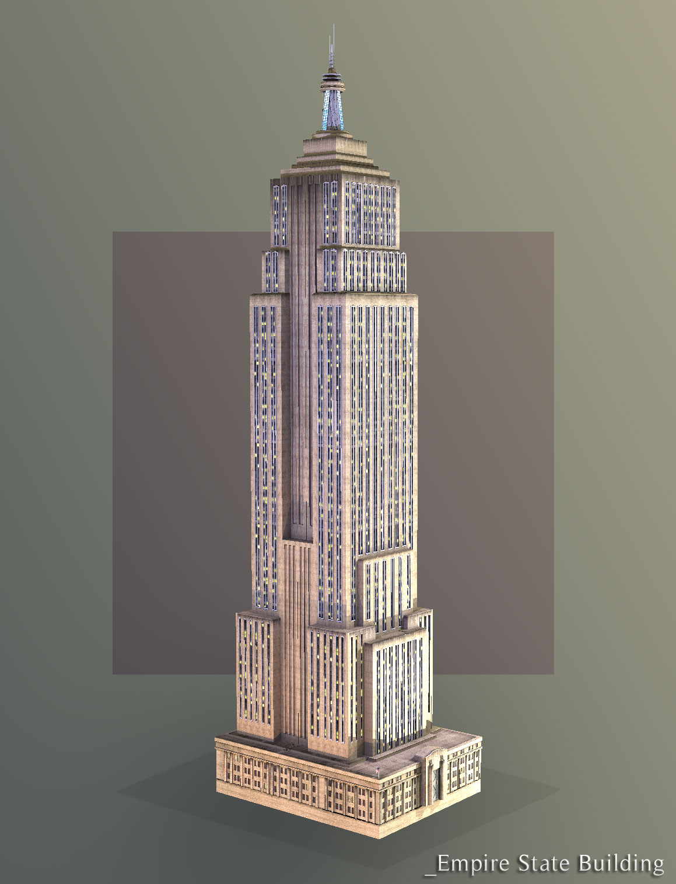

JOHN HANCOCK CENTER
Wikipedia:
John Hancock Center at 875 North Michigan Avenue in the Gold Coast area of Chicago, Illinois, is a 100-story, 1,127-foot^{[3]} (344 m) tall skyscraper, constructed under the supervision of Skidmore, Owings and Merrill,^{[3]} with chief designer and structural engineer Fazlur Khan^{[4]} and Bruce Graham. When completed in 1969,^{[3]} it was the tallest building in the world outside New York City. It is currently the fourth-tallest building in Chicago and the sixth-tallest in the United States, after the Willis Tower, the Empire State Building, the Bank of America Tower, the Trump Tower, and the Aon Center. When measured to the top of its antenna masts, it stands at 1,506 feet (459 m).^{[5]} The building is home to offices and restaurants, as well as about 700 condominiums and contains the highest-up residences in the world.^{[6]} This skyscraper was named for John Hancock Mutual Life Insurance Company, a developer and original tenant of the building.^{[7]}
Location: Chicago, Illinois, USA Completion Date: 1969
Height: 1,127 feet Stories: 100 Materials: Steel Facing Materials: Aluminum, glass
Engineer(s): Skidmore, Owings & Merrill
Today, the John Hancock Center in Chicago, Illinois, is affectionately known as "Big John," but it was not always this way. Located on North Michigan Avenue along Chicago's "Magnificent Mile," the skyscraper was controversial from the start for its enormous bulk and dark metal exterior. Eventually, it was celebrated for its very brashness, and today it remains one of Chicago's best-loved icons.
Currently, the John Hancock Center is the twelfth tallest building in the world. But to keep such a tall building standing in the "Windy City," engineers had to make the enormous structure super stiff. How did they do it? The John Hancock Center is actually a super-tall steel tube. Steel columns and beams are concentrated in the skyscraper's perimeter, and five enormous diagonal braces on the exterior walls of the skyscraper give it extra strength in the wind. The skyscraper also rises from 40,000 square feet at the base to 18,000 square feet at the summit. This tapered design provides additional structural stability against wind forces.
In order to reach the whopping height of 1,127, engineers knew that the enormous 384-million-pound tower needed caissons to prevent it from sinking into the soft ground. Today, the John Hancock Center rests on several caissons that extend down to bedrock. One of the caissons actually reaches 191 feet below the ground -- the deepest ever sunk in Chicago!
- The diagonals completely block the view from two windows on each floor. Ironically, a rental agent has transformed these "blocked" windows into something of a status symbol -- it actually costs more money to rent from these rooms!
- In 1997, the John Hancock Center was remodeled, and half of the 94th floor's southern windows were replaced with screens. Tourists can visit the "Skywalk," as it is called, and breathe the outside air and hear the noise of the city below.
- Offices occupy the lower floors of the 100-story skyscraper, and apartments are located on the upper floors of the building. Additional facilities include restaurants, health clubs, a swimming pool, and even an ice-skating rink.
- Antenna or spire 1,500 ft (457 m) Roof 1,127 ft (344 m) Top floor 1,078 ft (329 m)
- Technical details Floor count 100 Floor area 2,799,973 ft² (260,126 m²) Elevators 42, made by Otis Elevator Company^{[2]}

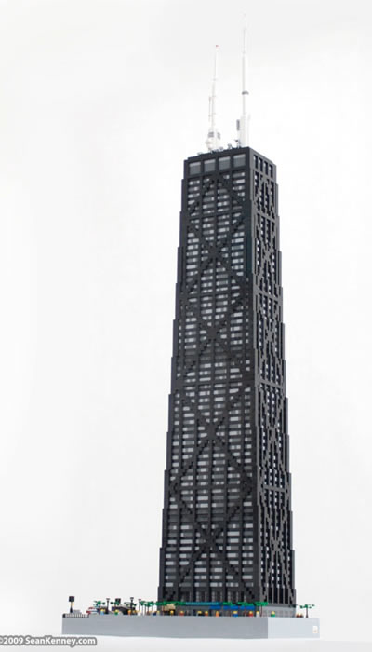
Transamerica Pyramid
Built on the location of the historic Montgomery Block, it has a structural height of 260 m (850 ft) and contains 48 floors of retail and office space. Construction began in 1969 and finished in 1972.
The Transamerica Pyramid was the tallest skyscraper west of the Mississippi from 1972 to 1974 surpassing the then Bank of America Center. It was then later surpassed by the Aon Center in Los Angeles.
- The top 64.6 m (212 ft) of the building is the spire. There are four cameras pointed in the four cardinal directions at the top of this spire forming a virtual observation deck. Four monitors in the lobby, whose direction and zoom can be controlled by visitors, display the cameras' views 24 hours a day. The building's façade is covered in crushed quartz, giving the building its pure white color.
- The four-story base of the building contains a total of 16,000 cu yd (12,000 m³) of concrete and over 300 mi (480 km) of steel rebar .
- It has 3,678 windows.
- The building's foundation is 9 feet (2.7 m) thick and was the result of a 24-hour continuous concrete pour.
- Only two of the building's 18 elevators reach the top floor.
- The original proposal called for a 1,150 ft (350 m) building, which would have been for one year the second-tallest completed building in the world. The proposal was rejected by the city planning commission on the grounds that it would have interfered with views of San Francisco Bay from Nob Hill.^{[1]}
- The building occupies the site that was the temporary home of A.P. Giannini's Bank of Italy after the 1906 San Francisco earthquake destroyed its office. Giannini founded Transamerica in 1928 as a holding company for his financial empire. Bank of Italy later became Bank of America.
- There is a plaque commemorating two famous dogs, Bummer and Lazarus, at the base of the building.
- The hull of the whaling vessel Niantic, an artifact of the 1849 California Gold Rush, lay almost exactly beneath the Transamerica Pyramid, and the location is marked by a historical plaque outside the building (California Historical Landmark #88).
- The aluminum cap is indirectly illuminated from within to balance the appearance at night.
- The two vertical external extensions allow preservation of useful interior space at the upper levels. One extension is the top of elevator shafts while the other is a smoke evacuation tower for fire-fighting.^{[5]}
- A glass pyramid cap sits at the top and encloses both aircraft warning light and a seasonal white beacon.
- At certain times of the year the glass cap will briefly cast a reflected sunlight gleam onto traffic crossing the San Francisco – Oakland Bay Bridge
Height is 853 - ft (256-m);
48-story building;
3,678 windows;
Gross floor area is about 530,000 ft² (49,000 m²);
18 elevators;
excavation depth is 52 ft.
According to the architect, William L. Pereira, the pyramid is the ideal shape for skyscrapers, offering the practical advantage of letting more air and light in the adjacent streets. The building would, he thought, be a statement of architectural sculpture. In the end, he turned out right. Not only does it have the appearance a modern sculpted monument, but if you look at the Transamerica Pyramid now, it also seems as if it was made to be built in San Francisco. From an economical point of view, a pyramid is not an efficient structure in terms of surface. The upper floors are very small and since there is a minimum of space needed for elevators, emergency stairs and so on, the percentage of useable space is very low. This is basically the main reason such a shape is rarely used.
However the unique shape was used so the architect could get around the strict building laws that imposed a certain ratio between the building's surface and its height. Thanks to its pyramid shape the tower was allowed to be much taller than if it had a conventional design.

The Building
The TransAmerica Pyramid was finished in 1972 and having a height of 260 meters (853ft), towers over the rest of the city. It has 48 floors with a 64 meter (210ft) high spire on top, covered with aluminum panels. The building owes its sparkling white color to the layer of crushed quartz that covers the rest of the building.


